**SERIES-PARALLEL CIRCUITS**

# **Objectives of the lab**

* Identify series-parallel relationships
* Recognize how each resistor in a given circuit is related to the other resistors

# **Learning Outcome:**

* After this lab, students will be able to measure the resistance in series and parallel in combination.
* Students will know how to use it to measure resistance in series and parallel by using DMM.

# **A series-parallel circuit consists of combinations of both series and parallel current paths.**

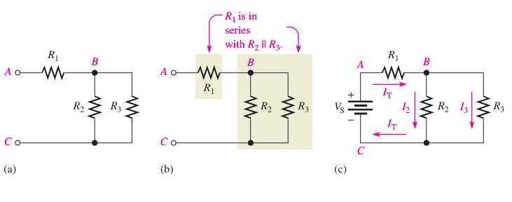

Figure 1(a) shows an example of a simple series-parallel combination of resistors. Notice that the resistance from point A to point B is R1. C is R2 and R3 in parallel (R2 R3). The resistance from point B to point The total resistance from point A to point C is in series with the parallel combination of R2 and R3, R1 as indicated in Figure 1(b). The term point can refer to either a node or a terminal.

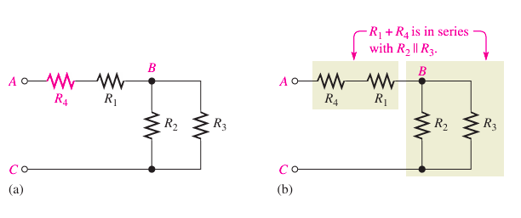

In Figure 2(a), another resistor (R4) is connected in series with The resistance between points A and B is now and this combination is in series with the parallel combination of and as illustrated in Figure 2(b).

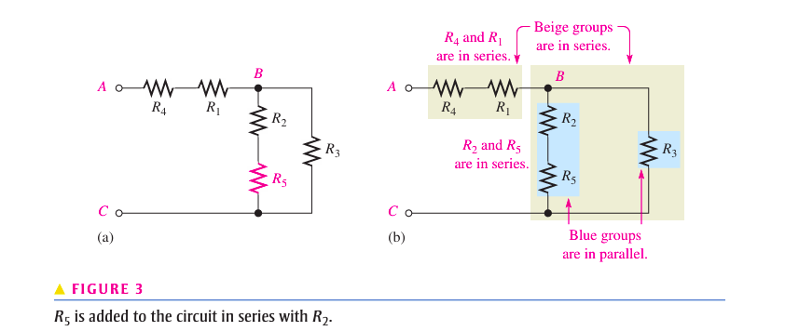

In Figure 3(a), is connected in series with The series combination of and is in parallel with This entire series-parallel combination is in series with the series combination of and as illustrated in Figure 3(b).

# **Equipment’s:**

• Multimeter (set to measure current)

• Breadboard

• Power supply (battery)

• Resistors

• Jumper wires

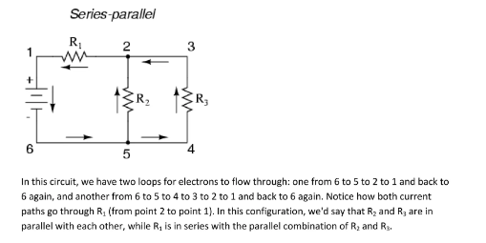

### **Measuring Current in Series**

1. **Set Up the Series Circuit**:
   * Connect your power supply to the breadboard.
   * Insert a resistor (or load) into the breadboard.
   * Connect the components in series: positive terminal of the power supply to one end of the resistor, and the other end of the resistor to the negative terminal of the power supply.
2. **Prepare the Multimeter**:
   * Set the multimeter to the current measurement mode (A for Amps, mA for milliamps).
   * Ensure the probes are correctly placed (usually red in the V, Ω, mA port and black in the COM port).
3. **Insert the Multimeter**:
   * Disconnect one lead of the resistor from the circuit.
   * Connect the multimeter probes in series with the resistor: one probe to the resistor’s lead and the other probe to the connection point on the breadboard where you removed the lead.
4. **Measure Current**:
   * Turn on the power supply.
   * Read the current value displayed on the multimeter.
5. **Reassemble the Circuit**:
   * After taking the measurement, disconnect the multimeter and reconnect the resistor to its original position.

### **Measuring Current in Parallel**

1. **Set Up the Parallel Circuit**:
   * Connect your power supply to the breadboard.
   * Insert two (or more) resistors in parallel: connect one end of each resistor to the same point (e.g., the positive terminal of the power supply), and connect the other ends together to a common point (e.g., the negative terminal).
2. **Prepare the Multimeter**:
   * Set the multimeter to the current measurement mode (A or mA).
3. **Insert the Multimeter**:
   * Choose one of the resistors for measurement.
   * Disconnect one lead of the resistor you want to measure.
   * Connect the multimeter probes in series with that resistor, just as you did in the series measurement.
4. **Measure Current**:
   * Turn on the power supply.
   * Read the current flowing through that resistor on the multimeter.
5. **Reassemble the Circuit**:
   * After the measurement, disconnect the multimeter and reconnect the resistor.

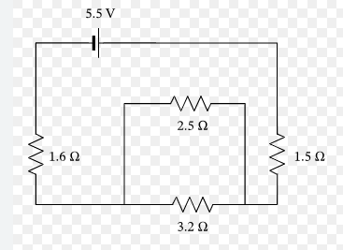

**FIG-2**

* + **In Series**: Current is constant; voltage drops across each component.
  + **In Parallel**: Voltage is constant across branches; current divides based on resistance.
  + **In Combination:** Current behavior can be analyzed by separating series and parallel parts, using the principles for each configuration.

**LAB TASK**

|  |  |  |  |  |  |  |
| --- | --- | --- | --- | --- | --- | --- |
| **Actions** | **Resistance     R1** | **Resistance     R2** | **Resistance     R3** | **Resistance in series** | **Resistance in Parallel** | **Total (R)** |
| **Measured** |  |  |  |  |  |  |
| **Computed** |  |  |  |  |  |  |
| **Error %** |  |  |  |  |  |  |

|  |  |  |  |  |  |  |
| --- | --- | --- | --- | --- | --- | --- |
| **Actions** | **Current I1** | **Current I2** | **Current I3** | **Current drop in parallel** | **Current in series** | **Total (I)** |
| **Measured** |  |  |  |  |  |  |
| **Computed** |  |  |  |  |  |  |
| **Error %** |  |  |  |  |  |  |

|  |  |  |  |  |  |
| --- | --- | --- | --- | --- | --- |
| **Actions** | **Voltage drop V1** | **Voltage drop V2** | **Voltage drop V3** | **Voltage drop in series** | **Total (V)** |
| **Measured** |  |  |  |  |  |
| **Computed** |  |  |  |  |  |
| **Error %** |  |  |  |  |  |

**Circuit Maker Implementation:**

**Equipment’s:**

1. V Source
2. Resistor
3. Ground

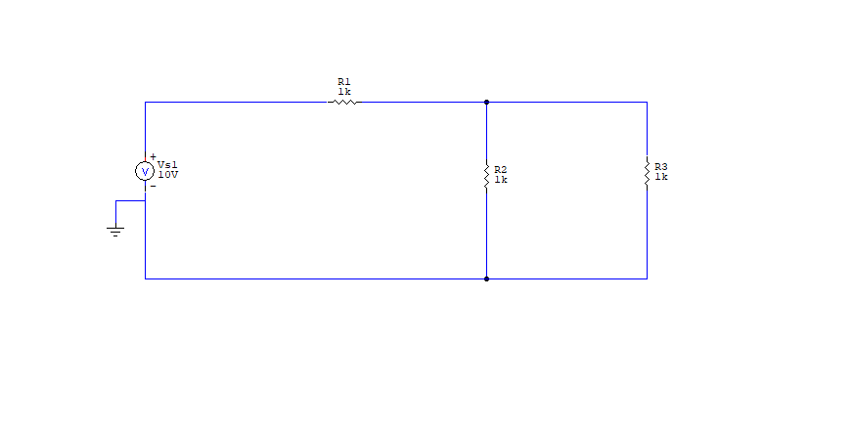  
**FIG 1 implementation**

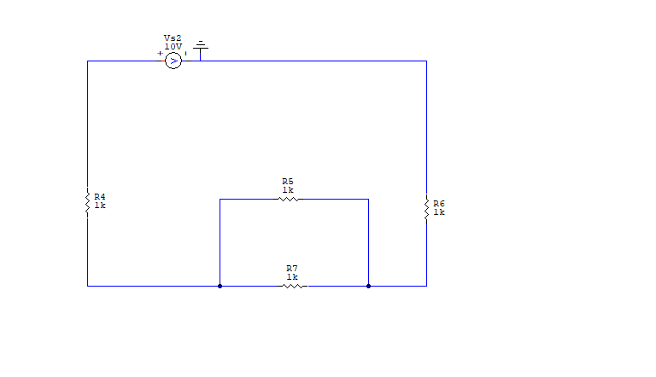

**FIG 2 implementation**

**Post lab Questions:**

1. Is the voltage drop same in simulation as you measured on breadboard?
2. Is the current drop same in simulation as you measured on breadboard?
3. What is the total resistance as you measured on breadboard?